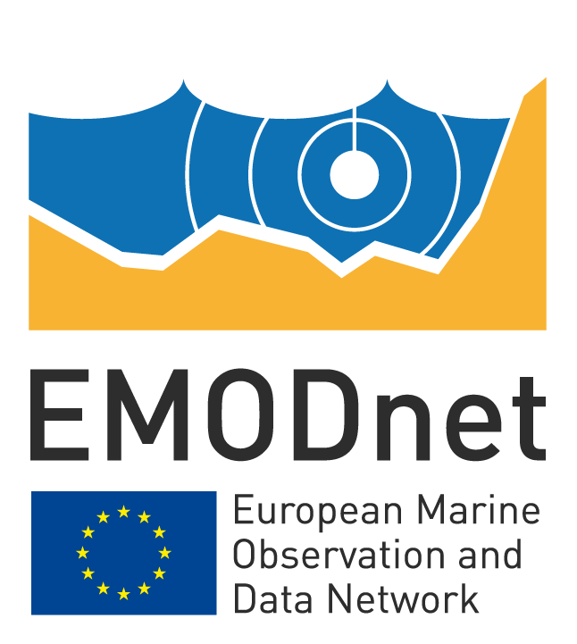
EMODnet Thematic Lot n° 1 – Geology
EASME/EMFF/2018/1.3.1.8 - Lot 1/SI2.811048
Start date of the project: 25/09/2019 - (24 months)
EMODnet Phase III – Quarterly Progress Report (3/8)
Reporting Period: 01/01/2020 – 31/03/2020

Contents
1 Highlights during the reporting period 3
2 Challenges encountered during the reporting period 4
3 Identified issues: status and actions taken 5
4 User feedback 6
5 Meetings held/attended since last report 7
6 Outreach and communication activities 8
7 Annex: Other documentation attached 11
8 Monitoring indicators 10

Disclaimer
The information and views set out in this report are those of the author(s) and do not necessarily reflect the official opinion of the EASME or of the European Commission. Neither the EASME, nor the European Commission, guarantee the accuracy of the data included in this study. Neither the EASME, the European Commission nor any person acting on the EASME's or on the European Commission’s behalf may be held responsible for the use which may be made of the information.

- Highlights in this reporting period
[Provide a short summary of the key achievements and/or events of interest to a wider audience within this reporting period you wish to highlight. Please make sure that progress in each of the tasks specified in Section 1.4.1 of the Tender Specifications is covered. For those tasks not experiencing significant progress, please state so. In addition, you can (but not required) also consider the indicators or any other of the reporting sections. Max 2 pages]
Task 1: Develop a common method of access to data held in repositories:
We continuously work on improving the services offered through the portal. Relying on OGC standards and building on open source software like Geoserver and GeoNetwork, we offer our data products through WMS, WFS, and CSW. This reporting period has focused on improving the INSPIRE compliancy on metadata descriptions and services.
Task 2: Construct products from one or more data sources that provide users with information about the distribution of parameters in time and space:
Several data products hold temporal components in the form of geological time aspects. Submerged landscapes being last in terms of recent ages.
Task 3: Develop procedures for machine-to-machine connections to data and data products:
All data products are listed on the “Services” page with links and examples to web services. Regarding metadata, we have a running service (GeoNetwork) enrolled into nightly harvesting by EMODnet main portal and EGDI MICKA.
Task 4: Maintain and further develop a thematic web portal allowing users to find, visualise and download data and promote the data and data products of the portal:
Several subtle improvements were introduced to the portal following recommendations from EASME and the EMODnet Secretariat in the previous quarterly report. The web portal continues to be improved in collaboration with other geological EU-projects. GeoERA is currently contributing to the behind-the-scenes management features of the web portal. Improvements are orchestrated to fit with the data management needs of EMODnet Geology.
Task 5: Ensure the involvement of regional sea conventions:
In spite of repeated attempts we haven’t yet succeeded to meet with any of the regional sea conventions
Task 6: Install a process to monitor performance and deal with user feedback:
We are linked to a monitoring system hosted by the main portal (Piwik/Matomo). Here we can login and extract performance and user statistics. The portal offers users the possibility to write feedback. We participate in all statistical initiatives put forward by the EMODnet Secretariat and Steering Committee.
Task 7: Operate a help desk offering support to users:
We continuously run our help desk according to rules set in the Tender Specifications.
Highlights of the different workpackages
WP1. Project Management. Many changes in plans due to the COVID-19 pandemic, see later in report.
WP1. Project Management. At the kick-off meeting in Athens in October 2019 general work plans for the entire project and detailed activities for the next six to twelve months were decided upon. These were to be checked and updated at the next project meeting in April 2020 in Utrecht, the Netherlands. However, this meeting has been cancelled due to the COVID-19 pandemic and a meeting with all partners is instead planned for the EMODnet Jamboree week in September.
WP1. Project Management. The EMODnet Geology Coordinator has actively coordianted the planning the work of the Caspian Sea task together with the Russian partner VSEGEI (EMODnet Geology subcontractor). CSEGEI as the regional coordinator of the Caspian Sea task made in early stage contacts with organisations in the Caspian Sea countries Kazakhstan, Azerbaijan, Iran and Turkmenistan. Subcontracts with organisations in these countries are in different stage, mainly delayed due to the COVID-19 pandemic. The only problem encountered is Turkmenistan from where VSEGEI has not got any reponse. Luckily that part of the Caspain Sea used to be a part of the Soviet Union and there are a lot of geological material obtained by investigations conducted by the USSR Ministry of Geology before 1991, as well as a number of modern publications. This will allow, if it is not possible to attract the Turkmenistan organisation to work on the EMODnet-Geology project, to create sets of geological maps for this part of the Caspian Sea in accordance with Tender specs.
WP1. Project Management. Many contributions from the different WP’s to the Geological Society of London Special Publication highlighting the work thus far.
WP2. Geological data specification and sourcing. Partners and subcontractors were at the kick-off meeting asked to report new data and metadata, which now are in the process of being collected. The same applies to the Caspian Sea subtask where VSEGEI has started collection of Russian data and is prepared for input of data from the other Caspian Sea countries. Some delays are to be expected due to the Corona virus as the Russian organisations are on Corona vacation throughout April. A similar situation is probable at least in Iran.
WP3. Seabed substrates. EMODnet Geology and EMODnet Geology WP3 seabed substrate products were presented in FINMARI Researcher Day Conference 10th March 2020 in Turku, Finland.
EMODnet Habitat lot has been informed about WP3 update plans and preliminary schedule. Their specific needs for seabed substrate data and schedule were inquired.
WP4. Sea-Floor Geology. Update of WP 4 Guidelines including workplan, provided to partners.
Geological Society of London Special Issue: From Continental Shelf to Slope - Mapping the Oceanic Realm: four contributions from the EMODnet Geology project have been accepted for publication. Coordinating Editor: Kristine Charlotte Asch, Ph.D./BGR/EMODnet Geology_WP4.
WP6. Geological Events and Probabilities. Guidelines of the current phase have been circulated to Partners. Fulfillment of the requirements evidenced by the evaluation of the Secretariat concerning products displayed on the Portal.
WP7. Marine Minerals. New datasets received from the Netherlands, Malta and Latvia. Updates on Aggregates and Hydrocarbons. A poster presentation was accepted by IGC36 emphasizing the collaboration between EMODnet Geology and the GeoERA MINDeSEA project, however, IGC36 postponed due to the COVID-19.
WP8: Submerged Landscapes. New submissions to add to the WP8 database have been received and are being assimilated into the WP8 update due to be submitted for uploading at end of April 2020.
- Challenges encountered during the reporting period
[Provide an overview of the main challenges encountered during the reporting period and the measures taken to address them, including those related to technical and data provision issues. Provide information in the table]

List of all challenges encountered during the reporting period
Main challenge | Measures taken
The ongoing spread of the SARS-CoV-2 virus (COVID-19) pandemic all over the globe might affect the progress of the project, especially staying on schedule/meeting the deadlines. | Meetings changed to teleconferences or postponed. Working on online meetings on specific WP tasks in small groups.  Some partner or subcontractor organisations are virtually closed for an unknown period of time, or it is difficult or very hard to get in contact with them.  The second EMODnet Geology project meeting has been postponed to be held back-to-back with the EMODnet Jamboree.  Planned meeting between TNO/Deltares and DG MARE on Phase 4 data products as well as future possibilities is being switched to a web conference later in April or early in May.
Cancellation of the next EMODnet-Geology meeting in April 2020.  Covid-19 | WP8 leader to organise zoom meeting with key partners April 2020 primarily to discuss palaeo-landscape reconstruction work forward, also to discuss possible conferences to showcase the WP8 work given the cancellation of many events due to Covid-19.
Cancellation of many meetings and conferences.  Covid-19 | These are essential platforms to showcase the work of the WP, and liaise with end-users. Discussion with all WPs to address this ‘advertisement’, ‘end-user’ and valuable platform for feedback needs to happen.
At the higher resolution required by the current phase volcanic fluid emissions may overlap to volcanic structures polygons, resulting in topologically inconsistent layers. | Additional separate layers have been introduced for volcanic fluid emissions in order to allow representation of detailed information preventing overlap.
New law introduced in Sweden that limits the published national geodata | 1:100 000 data within the 12nm territortial limit for Sweden was removed 24.1.2020, as Swedish military ordered. Unpublished 1:25 000 Swedish data was removed from the layer planned to be publish in September 2020.
Main challenge: Achieving adequate response time on the web maps is a constant challenge. GeoServer has only two options for improving response time; simplifying and caching but both are struggling with high-detailed polygons in multi-scale. | Hints to users are added to the user interface and we are investigating the possibility to move GeoServer to Docker and/or cloud.
Maintaining 130 data products through GeoServer’s user interface is very time consuming. | We are investigating the possibility to do mass updating across all data products through the GeoServer API or by updating the system files directly within GeoServer.

- Identified issues: status and actions taken
[Provide an overview of the issues identified by EASME (Table A), if any, during the reporting period, the status of those issues and actions taken to address them and/or roadmap with remaining actions planned to resolve the issues. You may also provide information about issues you identified yourself, but these need to be covered in a separate table (B)]

- Priority issue(s) identified and communicated by EASME/ DG MARE/ SECRETARIAT
Priority issue(s) | Status  (Pending/Resolved) | Action(s) taken / remaining actions planned | Date due
Put field-based coastal behaviour map back online | Pending. Under QC | Would be discussed at WP5 session during biannual meeting in Utrecht, online alternative yet to be planned. | May 31
Southern Mediterranean coastal behaviour dataset | Pending. | Practicalities to be discussed with Iain Shepherd and DG MARE team. In preparation, WebEx platform functionality was checked with Iain, date of meeting to be determined. | May 31
Metadata URL in XML format are missing for three layers:  ispra:landslide_pol_100k  ispra:geological_event_distribution  ispra:tsunami_pt2_250k | Resolved | Feedback to the Portal manager
Data URL not identified for the layer: events_and_probabilities | Resolved | Data URL for events_and_probabilities does not exist, because it is not a layer by itself but it is only the title grouping all WP6 layers
WP9. Data management, web portal and services. Comment from EASME. | Pending tasks from last report resolved. | Issues and Actions are listed in last report. | Q1/2020

- Other priority issue(s) identified by the thematic assembly group itself
Priority issue(s) | Status  (Pending/Resolved) | Action(s) taken / remaining actions planned | Date due
Finding a way to merge the field-based and satellite-based data products in the portal view, using the field-based data where available and up to date, and the satellite data where reliable to fill the gaps. | Pending | Currently, focus on technical implementation | June 30
Not all symbols display correctly on the Portal, even though they were created by means of the styles contained in .sld files as requested by the Portal manager | Pending | Elaborate a different library of symbols more suitable for Portal tools | End of 2020

- User feedback
[Provide a list of all user feedback received on your portal in chronological order within the reporting period. Indicate the type of the feedback received, a clear description of the query, and the actions undertaken to resolve the issue (e.g. update of metadata, fixing a particular issue with the map viewer). Indicate the status of the query (i.e. has the query been resolved or not yet), and if not provide an explanation why. List any useful feedback you received on your portal, your activities or those of other EMODnet projects/activities. Also provide any suggestions you have received for EMODnet case studies and/or future products/activities/events. Provide information in the table. If you wish to include the full user feedback in the report you can attach it in Annex]

Overview of user feedback and/or requests received during the reporting period
Date | Organisation | Type of user feedback (e.g. technical, case study, etc.) and short description of the feedback received | Response time | Status of user query: resolved/pending | Measures taken to resolve the query | Status: if not (yet) resolved/pending, explain reason why and expected timeline
11/02/2020 | European Commission, DG GROW | Request for a Pan-European offshore Aggregate map | 1 week | resolved | Generate a customized map
In general |  |  |  | Since last quarterly report we have not received any new feedback from users. (Christmas holidays and Covid-19 likely cause of lack of news).

- Meetings held/attended & planned
[List here the internal and external meetings held/participated by the contractant (e.g. meeting, conference, training (workshop), etc.) since the last quarterly report, and any important meetings or events planned in the future. Please add a short description on the meeting as well as the nature and volume of the audience. At the bottom of the table, provide the total number of events organised and events participated. Provide information in the two table]

- Meetings organised and attended
Date | Location | Type event (meeting, training (workshop), etc.) | Meeting to be attended / organised | Short description and main expected outcomes
10.3.2020 | Åbo Akademi, Turku, Finland | FINMARI Researcher Day -conference | A | EMODnet Geology project and WP3 products were presented and disseminated in the conference, 50 participants
12-14/02/2020 | Athens, Greece | EMSO-ERIC Conference | A | Presentation of the EMSO-ERIC preparing for the UN Decade of Ocean Science and planning potential future synergies with other infrastructures (60 participants)
SUM |  |  | O | Total # of meetings organised = 0
SUM |  |  | A | Total # of meetings attended = 2

- Meetings planned in the future
Date | Location | Type event (meeting, training (workshop), etc.) | Meeting Attended (A) / Organised (O) | Short description and main results (# participants, agreements made, etc.)
23/06/2020  (postponed due to the COVID-19 circumstances) | Rome, Sapienza University | Workshop | O | Presentation of a fluid emission database in Italian Seas, including data gathered by the Geological Survey of Italy within EMODnet Geology (80 participants)
November 2020 | New Delhi | IGC36 postponed | A | Poster presentation
April 2020 | Online | Key WP8 partners to forge plan for moving WP8 progress along despite Covid-19 disruption. | BGS to organise. | Discussion of timelines and objectives. Palaeo-landscape reconstruction work a priority.
- Outreach and communication activities
[Please list all the relevant communication/outreach activities or products you have developed/executed during this period (including presentations, lectures, trainings, demonstrations, workshops, etc., and development of communication materials such as brochures, videos, press releases, newsletters, etc.). At the bottom of the table, provide a total number for every type of communication activity you have developed/executed (e.g. total # of press releases, total # of presentations given, etc.). If you have planned any important outreach and/or communication activity, then please list these with their expected outcome. Provide information in the tables A for actions done and B for planned activities]

- Outreach and communication activities
Date | Communication action/ material | Short description (of the material, title, …) and/or link to the activity | Main results
28/02-01/03’2020 | Poster and stand | Public display of EMODnet WP7 activities at the 63rd Annual Irish Geological Research Meeting hosted by Geological Survey Ireland  https://www.gsi.ie/en-ie/events-and-news/events/Pages/IGRM2020.aspx | 200 people attended
10.3.2020 | Oral presentation (Henry Vallius) in FINMARI Researched Day conference | Harmonized geological maps of the European Seas – The EMODnet Geology project | 50 participants in the audience
10.3.2020 | Poster presentation (Susanna Kihlman) in FINMARI Researched Day conference | Compiling multiscale seabed substrate data for European seas – EMODnet Geology | 50 participants in the audience

- Planned outreach and communication activities
Date | Communication action/ material | Short description (of the material, title, …) and/or link to the activity | Main results expected
[Relevant scientific and/or popular publications (scientific papers, book chapters, conference papers, …) you published or of which you know they have been published using/referring to EMODnet data or data products during this reporting period must also be reported here. Provide information in the table.]

List of known publications using EMODnet data or data products
Date | Type and name of journal, conference, … | Publication title | Author(s) | Organisation(s)
In progress | Geological Society of London Special Issue: | From Continental Shelf to Slope - Mapping the Oceanic Realm | Editors. Asch. K.*) Kitazato, H, Vallius, H.  *) corresponding editor | Federal Institute For Geosciences and Natural Resources (BGR), Hannover, Germany; Tokyo University of Marine Science and Technology, Geological Survey of Finland (GTK), Espoo, Finland
31/01/2020 Submitted | Quarterly Journal of Engineering Geology and Hydrogeology - In: "Mapping the Geology and Topography of the European Seas (EMODnet)." | Submarine landslide: mapping the susceptibility in European seas | Innocenti C., Battaglini L., D’Angelo S. & Fiorentino A. | Geological Society of London.
13/02/2020 | EMSO-ERIC Conference | Potential application of harmonized geological events databases in geohazard assessment | Andrea Fiorentino | EMSO-ERIC
23/03/2020  submission of revised version  31/03/2020  accepted | Geological Field Trips and Maps (GFT&M) | Digital mapping of submerged areas: from the planning to the development of the final products | Battaglini L., D’Angelo S. & Fiorentino A. | Geological Society of Italy
30/03/2020 | Memorie Descrittive della Carta Geologica d’Italia, 105 | Inventory of fluid emissions in Italian Seas | D’Angelo S., Battaglini L. & Fiorentino A. (eds) | Geological Survey of Italy
31/03/2020  accepted | Geological Society of London Special Publication "From Continental Shelf to Slope - Mapping the Oceanic Realm" | Discover Europe’s seabed geology. The EMODnet concept of uniform collection and harmonization of marine data | Henry Vallius, Aarno Kotilainen, Kristine Asch, Andrea Fiorentino, Maria Judge, Heather A. Stewart, and Bjarni Pjetursson | Geological Survey of Finland (GTK), Espoo, Finland;  Federal Institute For Geosciences and Natural Resources (BGR), Hannover, Germany;  Istituto Superiore per la Protezione e la Ricerca Ambientale (ISPRA), Italy  The Geological Survey of Ireland (GSI), Ireland  British Geological Survey (BGS), UK  Geological Survey of Denmark and Greenland (GEUS), Denmark

- Monitoring indicators
[Please consult and complete the designated excel template on monitoring and progress indicators in annex, and provide a comment short explanation on numbers and trends in the table on for each indicator when possible/applicable. If any additional monitoring was done through other monitoring tools, please state clearly. Provide information in the table.]
Comments on the progress indicators in the excel template
Progress indicator | Comment
1.1 Volume and coverage of all available acquired data | We do not acquire data in this project.
1.2 Total number and the coverage of all built & external data products | Unchanged since last report.
2. Overview of all organisations supplying and approached to supply data and data products within reporting period | All partners contribute.
3. Interfaces to access or view data | No new interfaces.
4. Usage of data and data products per interface and per theme | Number of downloads show a positive trend typical for the first part of the year, where new projects are planned that require geological knowledge.
5. Distribution of users that have used the portal’s data and data products per organisation type and country, and their main use cases | Use cases reported by downloaders show interesting high rate of versatility.
6. External products (websites, apps, …) built on top of web-services: update since last quarterly report | A new base map was introduced to improve the visibility of marine data on the web-GIS.
7. Published use case and number of readings | No published use-cases during this reporting period.
8. Portal and Social Media visibility | See indicator 10.
9.1 Technical monitoring | The technical setup of monitoring is working satisfactory.
9.2 Portal user-friendliness | Important steps for improving user-friendliness introduced involving more web-GIS features and adapting to common standards for layout and styling of the main portal page.
10. Visibility & Analytics for web pages | We see a general increase of activity on all web pages except for the web-GIS. The latter could be explained by an unusual high activity in the previous quarter.
11. Visibility & Analytics for web sections | For statistics see figure Indicator_10 and Indicator_11 below
12. Average visit duration for web pages | Indicator 12 illustrates average time spent on the individual pages. A stable average below one minute for the entry page, tells us that users quickly move on to the actual contents. It’s difficult to determine what should be the success criteria for the rest of the pages. One could argue that users should quickly be able to move on. Or, one could argue that the more time spent on the page, the more value is available on the page. Either way, the statistics are fairly stable.
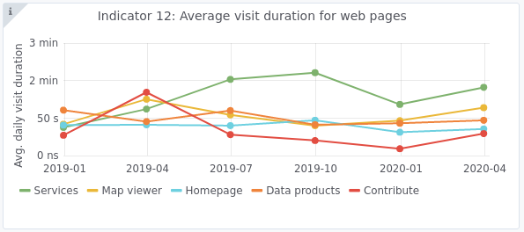
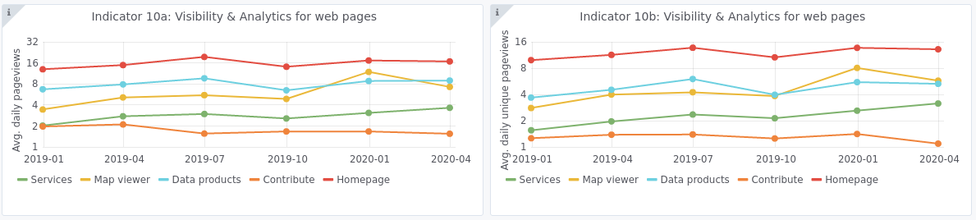
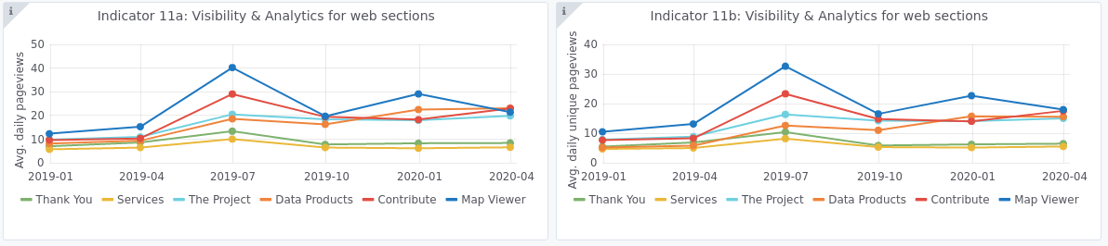

The monitoring numbers reported as part of the progress monitoring of EMODnet performance are collected through Matomo. In some cases, numbers from other monitoring systems may also be reported (e.g. Awstats, Google Analytics). Each system uses different technical approaches and therefore has its strengths and shortcomings. Therefore, results are indicative and care should be taken with interpreting absolute numbers or comparing results from different tools. It is often more sensible to consider trends over time collected by the same monitoring tool.

- Annex: Other documentation attached
[List in Annex if you wish to provide any additional information.]

